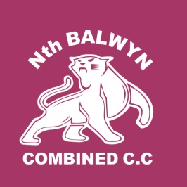
AGM 2014 AGENDA
Wednesday, 7th May, 2014
START: 7.30PM
Gordon Barnard Reserve Pavilion

- Members Present and Apologies.
- Confirm the minutes of the last preceding Annual General Meeting:
  - Held May 2nd, 2013.
- Receive from the Committee reports of the Association during the last preceding financial year:
  - Presidents, Secretary and Treasurers Reports.
- To elect officers of the Association and the ordinary members of the Committee:
  - President, Vice President, Secretary, Treasurer and Committee Members
- General Business:
  - Junior Committee (Co-ordinator, Secretary, Treasurer and Coach) nominations
  - Grounds Committee (Greythorn Park & Gordon Barnard) nominations
  - Chairman of Selectors nominations
  - Coach / Club Captain / Professional player
  - Captains Nominations
  - Life Membership Nominations
- Other Business

BE A PART OF YOUR CLUBS FUTURE
Nomination form:
Bring on the night or post to PO Box 1148, Greythorn, 3104
Note: Use blank spaces if need extra space, just fill in position.
All positions considered vacant and may not be elected at the time of the AGM.

North Balwyn Combined Cricket Club Nominations form
Position | Nominee | Nominator | Seconder
President
Vice President
Secretary
Treasurer
General
General
General
Junior*
Greythorn Park Rep
Gordon Barnard Rep
Chairman of Selectors
Captain#
* Insert either: Coordinator, Secretary, Treasurer or Coach
# Insert either: 1st, 2nd etc. XI

